
UK Regional Trade in Goods Statistics
Quarter 4 2018

About this release
These statistics provide a useful breakdown of the flows of goods imported and exported between regions of the UK and partner countries. Supporting tables, visuals and data can be found at uktradeinfo.com

In this publication
Overview Exports p2
Overview Imports p6
England p10
Wales p14
Scotland p18
Northern Ireland p22
English Regions p26
Imports into English Regions p28
Map of UK Regions p30
Explanatory Notes p31

Summary
In the year to December 2018, the overall value of UK trade in goods exports increased by 2.6% compared with the same period last year. Similarly, the overall value of imports also increased by 2.6%.
On a regional basis:
- All UK countries saw an increase in the value of exports.
- All four saw an increase in imports.
- There was an increase in annual export value for all English regions except the North West, the West Midlands and the East.
- There was an increase in annual import value for all English regions except the East and the South West.

Figure 1: UK Imports and Exports by Region, year to December 2018
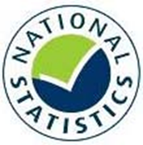
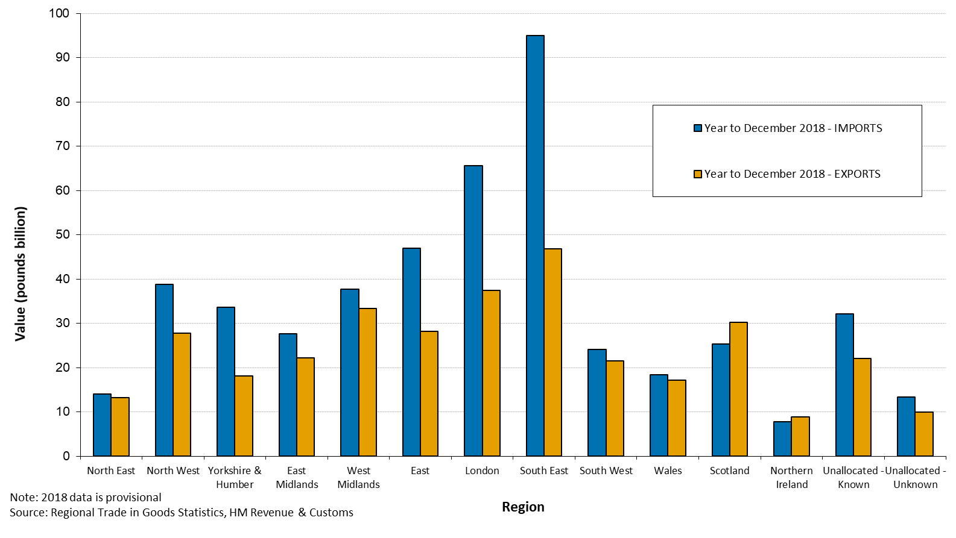

Website: https://www.uktradeinfo.com
Email: uktradeinfo@hmrc.gov.uk
Statistical contacts: James Durnford 03000 594250
Media contact: HMRC Press Office 03000 585018
Coverage: United Kingdom
Theme: Business and Energy
Released: 07 March 2019
Next release: 06 June 2019
The total annual value of UK exports increased by 2.6% to £337 billion in the year ending December 2018 compared with the same period the previous year.
Overview Exports
Figure 2 shows the total value of UK exports by region for the three annual periods ending December 2016, December 2017 and December 2018.
When comparing the annual period ending December 2018 with the annual period ending December 2017:
- Value of exports from England, Wales, Scotland and Northern Ireland increased during the year.
- All 9 of the English regions except the North West, the West Midlands and the East experienced increases in the value of exports.
When comparing the annual period ending December 2018 with year ending December 2016, there was an increase of UK exports from £291 billion to £337 billion. This is an increase of £46 billion or 16%.
- Value of exports from England, Wales, Scotland, and Northern Ireland increased during this period by 13%, 17%, 25% and 13% respectively.
- Value of exports from all nine English regions saw an increase.

Figure 2: UK Exports by Region, 2016 Q1 – 2018 Q4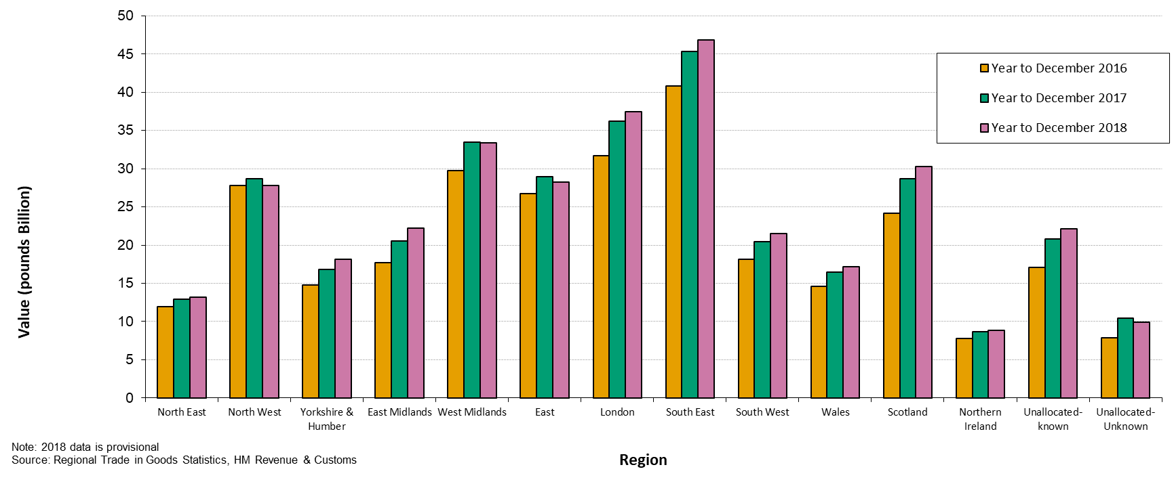

Figure 3 shows the breakdown by region of UK exports for the 12 month period ending December 2018.
Overview Exports: Regional Breakdown
- UK exports were dominated by those from England. They accounted for 74 % of value.
- Within the English regions; South East, London and West Midlands accounted for the greatest shares with 14, 11 and 10 % of UK exports respectively.
- North East had the lowest share in the English regions of 3.9 %.
- Northern Ireland, Wales and Scotland accounted for 2.6, 5.1 and 9.0 % of exports respectively.

Figure 3: UK Exports by country / region, year ending Q4 2018 – percentage of value
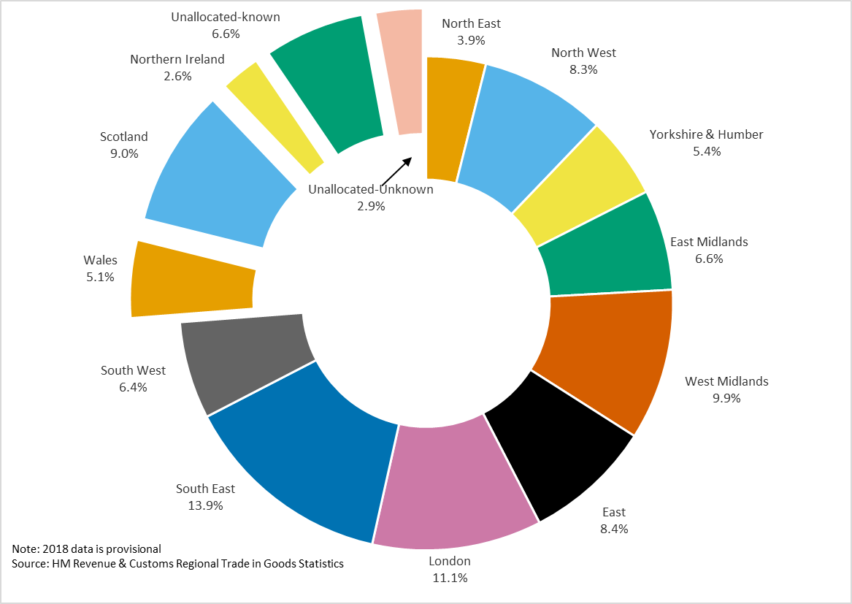
The business count is derived from trade declarations and is a count of all VAT Registered businesses importing and exporting. Where businesses have branches in multiple regions, there are two ways of deriving the count:
Overview Exports: Exporter Business Count
• Whole Number Method: A business will be counted as one in every region they have employees. This represents the actual count of businesses in any region. However, it will mean the sum of the business count for each region will be greater than that for the UK.
• Proportion Method: A business will be counted as a fraction in each region they trade based on the proportion of their employees in each region. An individual business counts as one business in the UK. The sum of businesses (whole and fractions) gives the total business count for a region.
We analyse results from both methods in this commentary. A quarter-on-quarter comparison enables us to measure seasonal changes of business counts.
For the UK, the number of exporting businesses increased by 0.9 % between quarter 4 2017 and quarter 4 2018, from 109,700 to 110,800.

Figure 4: Percentage Change in Number of Exporters between Q4 2017 and Q4 2018 - Whole Number Method
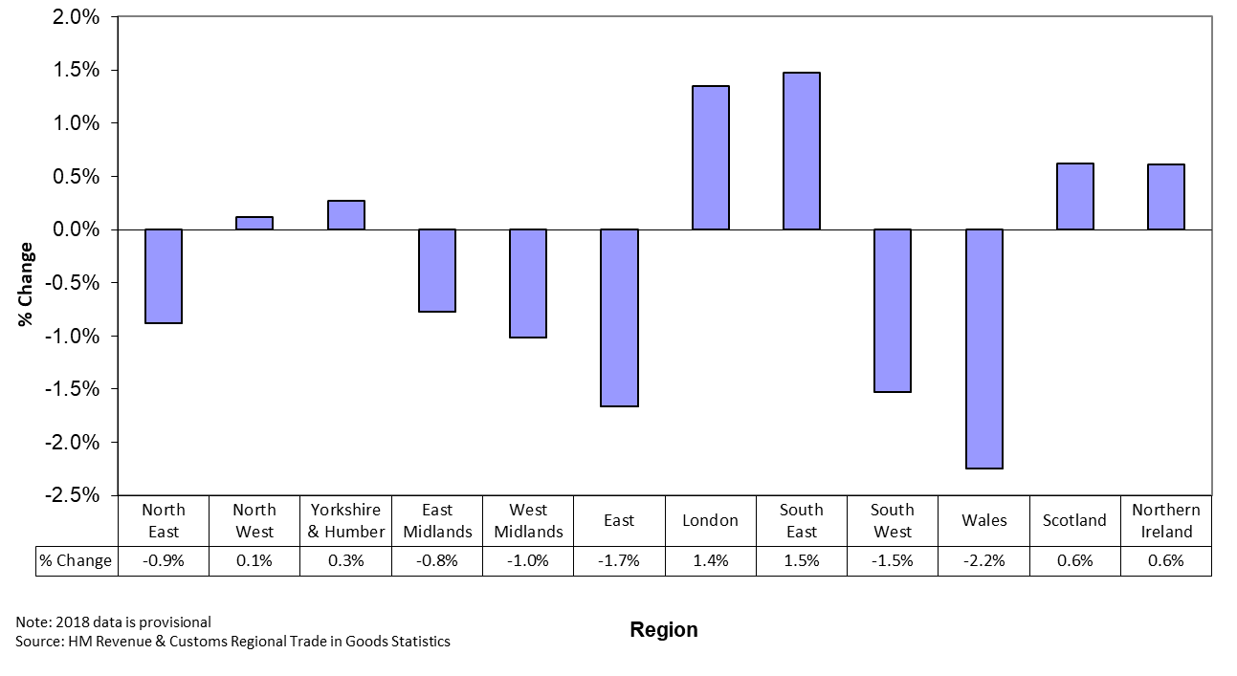
Figure 4 shows that under the whole number method:
• The number of exporters increased for all UK countries except Wales and for the English regions North West, Yorkshire and the Humber, London and South East.
• South East experienced the largest percentage rise in exporting businesses, a rise of 1.5 %.
• Wales saw the largest percentage fall, 2.2 %.
Figure 5: Percentage Change in Number of Exporters between Q4 2017 and Q4 2018 - Proportion Method
Overview Exports: Exporter Business Count

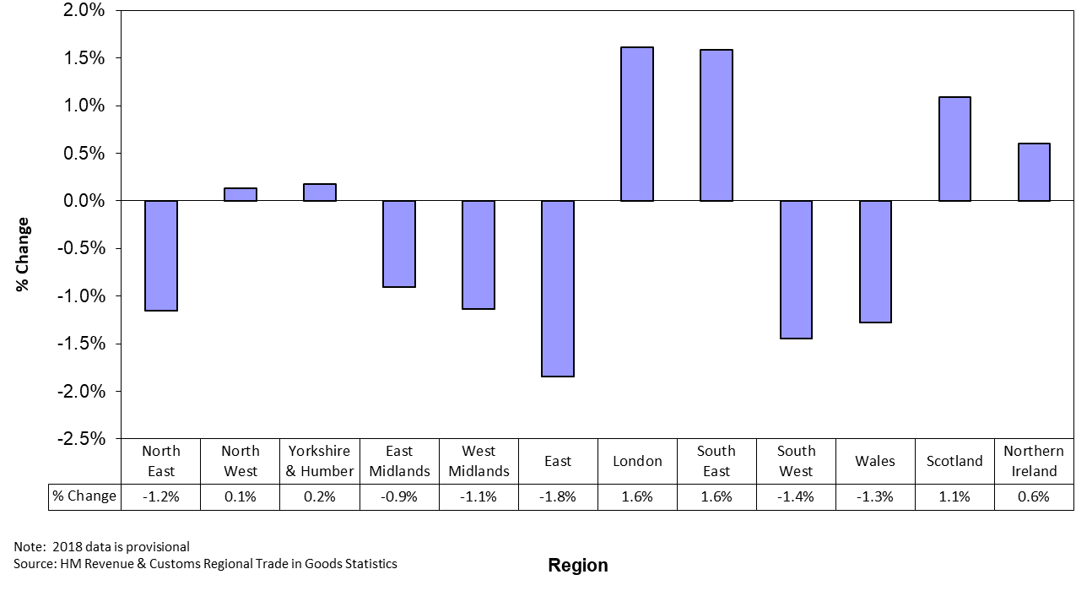
Figure 5 shows that under the proportion method:
• The number of exporters increased for all UK countries except Wales and for English regions the North West, Yorkshire and the Humber, London and the South East.
• London and the South East experienced the largest percentage rises in exporting businesses, rises of 1.6 %.
• The East saw the largest percentage decrease, 1.8 %.
The total annual value of UK imports increased by 2.6 % to £481 billion in the year ending December 2018 compared with the same period the previous year.
Overview Imports

Figure 6: UK Imports by Region, 2016 Q1 – 2018 Q4
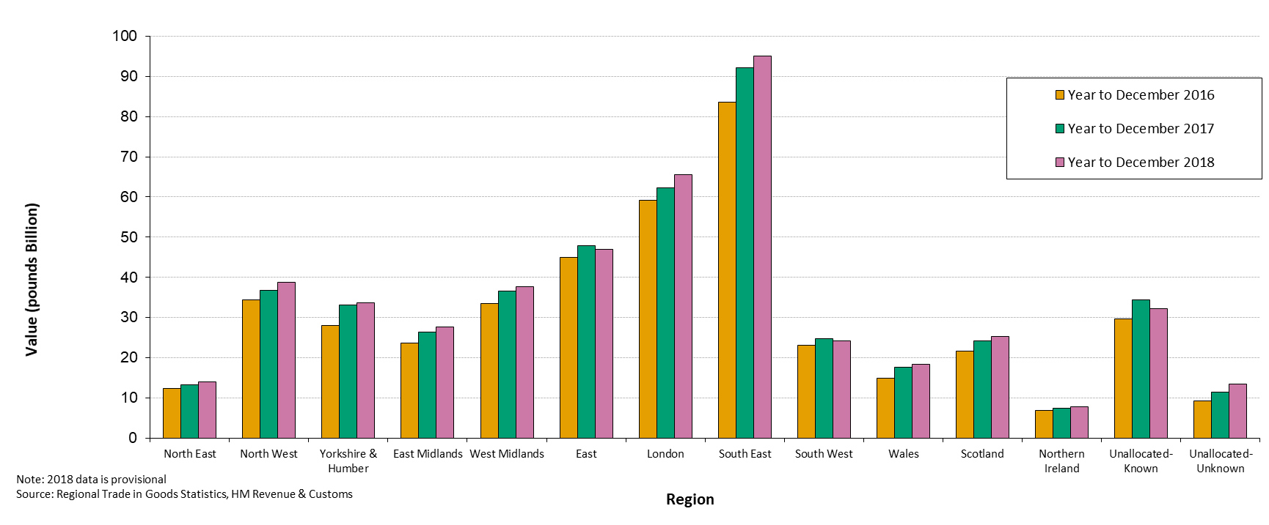

Figure 6 shows the total value of UK imports by region for the 3 annual periods ending December 2016, December 2017 and December 2018.
When comparing the annual period ending December 2018 with the annual period ending December 2017
- There was a rise in import value during the year for England, Wales, Scotland and Northern Ireland.
- Among the English regions, there were increases for all English regions except the East and the South West.
When comparing the annual period ending December 2018 with year ending December 2016, there was an increase of annual UK imports from £425 billion to £481 billion. This was an increase of £55 billion or 13 %.
- Imports into England, Wales, Scotland and Northern Ireland increased during this period by 12 %, 23 %, 17 % and 12 % respectively.
- All English regions experienced an increase.
Overview Imports: Regional Breakdown
Figure 7: UK Imports by country / region, year ending Q4 2018 – percentage of value 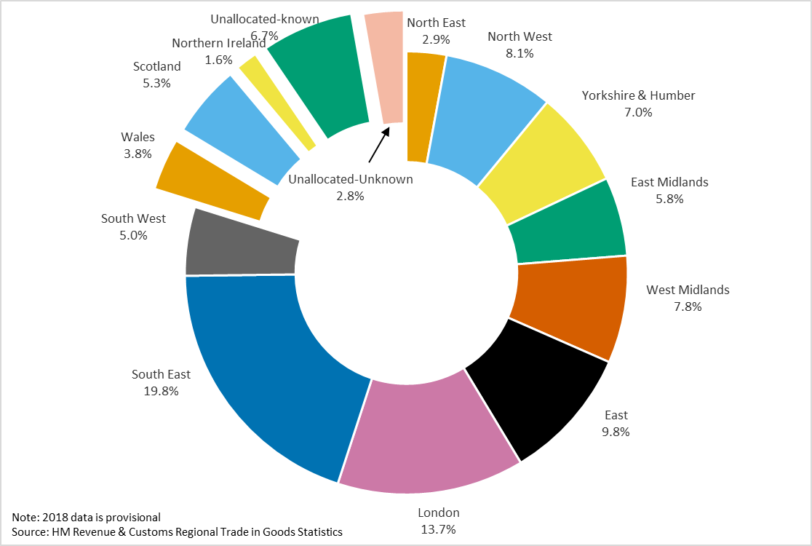

Figure 7 shows the breakdown by region of UK imports for the 12 month period ending December 2018.
- UK imports were dominated by those to England. They accounted for 80 % of value.
- Within the English regions; South East, London and the East accounted for the greatest shares with 20, 14 and 10 % of UK imports respectively.
- North East had the smallest share of England’s imports. It accounted for 2.9 % of UK imports.
- Northern Ireland, Wales and Scotland accounted for 1.6, 3.8 and 5.3 % of imports respectively.

Similar to the exporters count, 2 ways are used to derive the count especially when dealing with businesses which have branches in multiple regions, the whole number method and the proportion method.
Overview Imports: Importer Business Count
For the UK, the number of importing businesses increased by 3.1 % between quarter 4 2017 and quarter 4 2018, from 167,500 to 172,700.

Figure 8: Percentage Change in Number of Importers between Q4 2017 and Q4 2018 – Whole Number Method
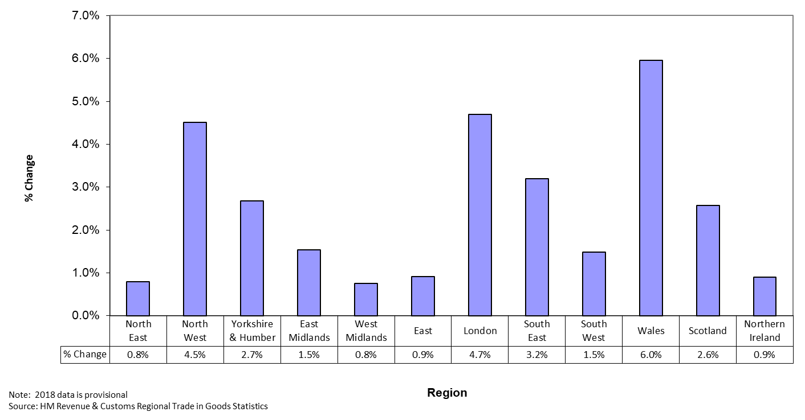

Figure 8 shows that under the whole number method
- The number of active importers increased in all countries of the UK.
- The number of active importers increased in all English regions.
- Wales saw the largest percentage increase, 6.0 %.
- The North East and the West Midlands had the smallest increases of 0.8 %.
Overview Imports: Importer Business Count
Figure 9: Percentage Change in Number of Importers between Q4 2017 and Q4 2018 – Proportion Method
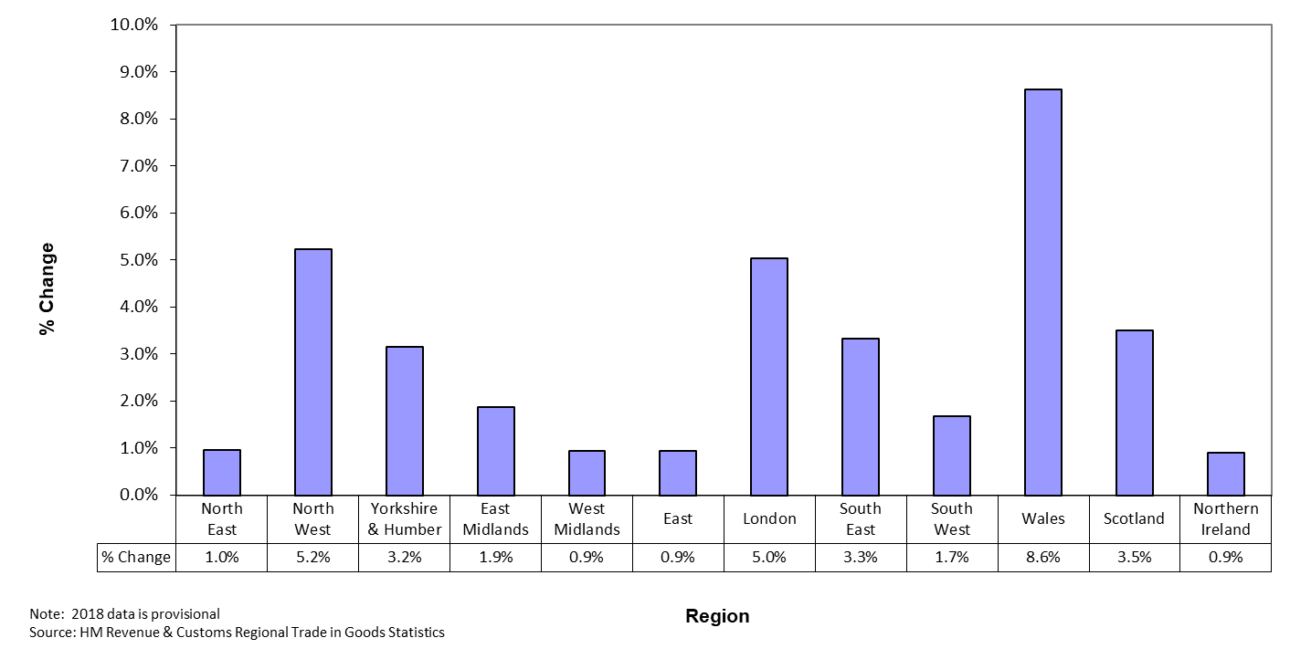
Figure 9 shows that under the proportion method:
- The number of active importers increased in all countries of the UK.
- The number of active importers increased in all English regions.
- Wales saw the largest percentage increase, 8.6 %.

- West Midlands, the East and Northern Ireland saw the smallest increases of 0.9 %.

Table 1: England - Top five export partners, year ending December 2018
Country | Total  Year ending Dec 2018  £ millions | Total  Year ending Dec 2017  £ millions | % Change from Dec 2017 | % Total Exports in year ending Dec 2018
USA | 36,466.5 | 34,627.9 | 5.3 | 14.7
Germany | 25,292.6 | 25,595.4 | -1.2 | 10.2
France | 17,100.5 | 16,866.4 | 1.4 | 6.9
Netherlands | 16,453.2 | 14,628.8 | 12.5 | 6.6
China | 13,558.4 | 12,903.6 | 5.1 | 5.5
Others | 139,693.4 | 138,728.5 | 0.7 | 56.2
Total EU | 122,426.0 | 118,966.5 | 2.9 | 49.3
Total Non-EU | 126,138.6 | 124,384.0 | 1.4 | 50.7
Grand Total | 248,564.5 | 243,350.5 | 2.1 | 100.0
Note: 2018 data is provisional
Source: HM Revenue & Customs Regional Trade in Goods Statistics

Exports from England - Partner country analysis

Value of exports from England increased by 2.1 % during the year ending December 2018 compared with the previous year. This was compared with an increase of 2.6 % for the UK as a whole.
England’s exports to the EU increased by 2.9 % during the last year, while exports to non-EU countries increased by 1.4 %. The market share for EU exports was 50 %, an increase of less than one percentage point from the previous year.
- Four of the top five export partners saw an increase in value over the last 12 months. The exception was Germany.
- The largest value increase in export trade was to USA (up £1.8 billion, 5.3 %) followed by the Netherlands (up £1.8 billion, 12 %).
- The largest value decrease in exports was to Oman (down £776 million, 47 %) followed by UAE (down £695 million, 13 %).

Table 2: England - Top five commodities for export, year ending December 2018
SITC section and Description | Total  Year ending Dec 2018  £ millions | Total  Year ending Dec 2017  £ millions | % Change from Dec 2017 | % Total Exports in year ending Dec 2018
7: Machinery & transport equipment | 110,509.2 | 109,654.8 | 0.8 | 44.5
8: Miscellaneous manufactured articles | 38,975.6 | 38,604.1 | 1.0 | 15.7
5: Chemicals & related products | 37,792.9 | 37,794.7 | 0.0 | 15.2
6: Manufactured goods classified chiefly by material | 24,578.7 | 23,346.2 | 5.3 | 9.9
3: Mineral fuels, lubricants & related materials | 17,705.5 | 15,026.9 | 17.8 | 7.1
Other SITCs | 19,002.7 | 18,923.6 | 0.4 | 7.6
Grand Total | 248,564.5 | 243,350.5 | 2.1 | 100.0
Note: 2018 data is provisional
Source: HM Revenue & Customs Regional Trade in Goods Statistics
Exports from England - Commodity analysis
The value of exports increased during the year for all of England’s top five commodities.
- ‘Machinery & transport equipment’ continued to dominate exports from England; its share of England’s exports was 44 %.
- Six SITC sections increased. The largest increases were ‘Mineral fuels, lubricants & related materials’ (up £2.7 billion, 18 %), and ‘Manufactured goods classified chiefly by material’ (up £1.2 billion, 5.3 %).
- The largest decrease was for ‘Animal & vegetable oils, fats & waxes’ (down £41 million, 10 %).
At the more detailed commodity classification SITC division level, 24 of the 66 SITC divisions decreased in export value during the year.
- The largest decrease was in ‘Other transport equipment’ (down £1.1 billion, 10 %).
- The largest increases were in divisions ‘Petroleum, petroleum products & related materials’ (up £3.1 billion, 24 %) and ‘Power generating machinery & equipment’ (up £1.2 billion, 5.6 %).

Imports into England - Partner country analysis
Table 3: England - Top five import partners, year ending December 2018
Country | Total  Year ending Dec 2018  £ millions | Total  Year ending Dec 2017  £ millions | % Change from Dec 2017 | % Total Imports in year ending Dec 2018
Germany | 59,585.4 | 59,633.8 | -0.1 | 15.5
China | 35,524.1 | 35,090.7 | 1.2 | 9.3
Netherlands | 35,270.8 | 33,468.0 | 5.4 | 9.2
USA | 28,710.5 | 27,876.2 | 3.0 | 7.5
France | 22,788.5 | 21,988.8 | 3.6 | 5.9
Others | 201,663.1 | 195,237.2 | 3.3 | 52.6
Total EU | 218,248.8 | 212,837.3 | 2.5 | 56.9
Total Non-EU | 165,293.6 | 160,457.2 | 3.0 | 43.1
Grand Total | 383,542.4 | 373,294.6 | 2.7 | 100.0
Note: 2018 data is provisional
Source: HM Revenue & Customs Regional Trade in Goods Statistics

Imports into England increased by 2.7 % during the year ending December 2018; this compared with a 2.6 % increase in imports to the UK as a whole.
- EU partner countries accounted for 57 % of England’s imports during the year; a decrease of less than one percentage point from the previous year.
- Germany remained the top import partner for England by a wide margin. For the latest annual period it accounted for 16 % of all imports into England, a decrease of less than one percentage point compared with the previous year.
- Imports from the other top five import partners increased compared with the previous year.
- The largest value increases were for imports from the Netherlands (up £1.8 billion, 5.4 %) followed by Russia (up £1.7 billion, 41 %).
- The largest value decreases were for imports from Spain (down £1.3 billion, 11 %) followed by Qatar (down £1.2 billion, 53 %).
Imports into England - Commodity analysis
Table 4: England - Top five commodities imported, year ending December 2018
SITC section and Description | Total  Year ending Dec 2018  £ millions | Total  Year ending Dec 2017  £ millions | % Change from Dec 2017 | % Total Imports in year ending Dec 2018
7: Machinery & transport equipment | 149,548.7 | 151,838.6 | -1.5 | 39.0
8: Miscellaneous manufactured articles | 61,689.5 | 61,749.9 | -0.1 | 16.1
6: Manufactured goods classified chiefly by material | 44,455.4 | 41,816.5 | 6.3 | 11.6
5: Chemicals & related products | 44,198.2 | 43,138.7 | 2.5 | 11.5
3: Mineral fuels, lubricants & related materials | 36,642.9 | 28,699.6 | 27.7 | 9.6
Other SITCs | 47,007.7 | 46,051.3 | 2.1 | 12.3
Grand Total | 383,542.4 | 373,294.6 | 2.7 | 100.0
Note: 2018 data is provisional
Source: HM Revenue & Customs Regional Trade in Goods Statistics

The value of imports increased during the year for 3 of England’s top 5 commodities.
- ‘Machinery & transport equipment’ continued to dominate England’s imports, accounting for 39 % of total import value, a decrease from 41 % the previous year.
- The largest value increases at SITC section level were in ‘Mineral fuels, lubricants & related materials’ (up £7.9 billion, 28 %) and ‘Manufactured goods classified chiefly by material’ (up £2.6 billion, 6.3 %).
- The largest value decreases at SITC section level was in ‘Machinery & transport equipment’ (down £2.3 billion, 1.5 %) and ‘Animal & vegetable oils, fats & waxes’ (down £118 million, 10 %).

At the more detailed commodity classification SITC division level, 23 of the 66 SITC divisions decreased in import value over the 12 months.
- The largest reduction was in ‘Other transport equipment’ (down £2.9 billion, 29 %) and ‘Road vehicles (including air cushion vehicles)’ (down £2.1 billion, 4.1 %). .
- The largest increases were in divisions ‘Petroleum, petroleum products & related materials’ (up £5.7 billion, 26 %) and ‘Manufactures of metal n.e.s.’ (up £2.4 billion, 28 %).

Exports from Wales - Partner country analysis

Table 5: Wales - Top five export partners, year ending December 2018
Country | Total  Year ending Dec 2018  £ millions | Total  Year ending Dec 2017  £ millions | % Change from Dec 2017 | % Total Exports in year ending Dec 2018
Germany | 3,118.3 | 3,234.7 | -3.6 | 18.2
France | 2,680.5 | 2,754.7 | -2.7 | 15.6
USA | 2,445.2 | 2,288.6 | 6.8 | 14.2
Irish Republic | 1,511.3 | 992.4 | 52.3 | 8.8
Netherlands | 746.3 | 695.9 | 7.2 | 4.3
Others | 6,672.5 | 6,512.7 | 2.5 | 38.9
Total EU | 10,518.3 | 9,962.7 | 5.6 | 61.2
Total Non-EU | 6,655.8 | 6,516.3 | 2.1 | 38.8
Grand Total | 17,174.1 | 16,479.0 | 4.2 | 100.0
Note: 2018 data is provisional
Source: HM Revenue & Customs Regional Trade in Goods Statistics

Export values from Wales increased by 4.2 % during the year ending December 2018.
- Exports from Wales to the EU increased by 5.6 % during the last year, while exports to non-EU countries increased by 2.1 %.
- EU partner countries dominate the export market from Wales, receiving 61 % of goods exported. This was an increase of one percentage point compared with the previous year.
- Germany was the top export partner. It accounted for 18 % of exports from Wales for the year ending December 2018, a decrease of 3.6 % for the previous year.
- Of the top 5 export partners only the top 2, Germany and France saw a decrease in value over the last 12 months.
- The partner countries where export values increased most during the year were Irish Republic (up £519 million, 52 %) and the USA (up £157 million, 6.8 %).
- The partner countries with the largest value decreases in exports over the year were Germany (down £116 million, 3.6 %) followed by France (down £74 million, 2.7 %).
Exports from Wales - Commodity analysis

Table 6: Wales - Top five commodities for export, year ending December 2018
SITC section and Description | Total  Year ending Dec 2018  £ millions | Total  Year ending Dec 2017  £ millions | % Change from Dec 2017 | % Total Exports in year ending Dec 2018
7: Machinery & transport equipment | 8,513.1 | 8,744.1 | -2.6 | 49.6
3: Mineral fuels, lubricants & related materials | 2,303.9 | 1,613.5 | 42.8 | 13.4
6: Manufactured goods classified chiefly by material | 2,166.9 | 2,040.5 | 6.2 | 12.6
5: Chemicals & related products | 1,951.9 | 1,936.1 | 0.8 | 11.4
8: Miscellaneous manufactured articles | 1,359.4 | 1,313.1 | 3.5 | 7.9
Other SITCs | 878.9 | 831.8 | 5.7 | 5.1
Grand Total | 17,174.1 | 16,479.0 | 4.2 | 100.0
Note: 2018 data is provisional
Source: HM Revenue & Customs Regional Trade in Goods Statistics

The value of exports from Wales increased during the year for 4 of the top 5 commodities.
- Exports from Wales continued to be dominated by ‘Machinery & transport equipment’ which made up 50 % of the trade a decrease of three percentage points from the previous year.
- The SITC sections with the largest value increases were ‘Mineral fuels, lubricants & related materials (up £690 million, 43 %) and ‘Manufactured goods classified chiefly by material’ (up £126 million, 6.2 %).
- The largest value decreases were for ‘Machinery & transport equipment’ (down £231 million, 2.6 %) and ‘Beverages & tobacco’ (down £3.4 million, 12 %).
At the more detailed commodity classification SITC division level, 25 of the 66 SITC divisions decreased in export value over the year.
- The largest decreases were in ‘Other transport equipment’ (down £232 million, 5.3 %) and in ‘Power generating machinery & equipment’ (down £135 million, 6.6 %).
- The largest increases were in divisions ‘Petroleum, petroleum products & related materials’ (up £670 million, 43 %) and ‘Iron and Steel’ (up £131 million, 15 %).

Imports into Wales - Partner country analysis
Table 7: Wales - Top five import partners, year ending December 2018
Country | Total  Year ending Dec 2018  £ millions | Total  Year ending Dec 2017  £ millions | % Change from Dec 2017 | % Total Imports in year ending Dec 2018
USA | 2,971.0 | 2,446.7 | 21.4 | 16.2
Germany | 1,913.7 | 2,021.6 | -5.3 | 10.4
China | 1,141.9 | 1,174.2 | -2.8 | 6.2
Netherlands | 1,046.1 | 1,042.7 | 0.3 | 5.7
France | 808.6 | 889.1 | -9.1 | 4.4
Others | 10,442.9 | 10,038.4 | 4.0 | 57.0
Total EU | 7,152.3 | 7,387.5 | -3.2 | 39.0
Total Non-EU | 11,171.9 | 10,225.2 | 9.3 | 61.0
Grand Total | 18,324.2 | 17,612.7 | 4.0 | 100.0
Note: 2018 data is provisional
Source: HM Revenue & Customs Regional Trade in Goods Statistics

Imports to Wales increased in value by 4.0 % during the year ending December 2018.
- Of the top five imports partners, only two saw an increase in value compared with the previous year.
- USA was the largest import partner for Wales. It accounted for 16 % of imports into Wales as a result of a 21 % increase in the last year.
- The largest increases in imports were from USA (up £524 million, 21 %) followed by Algeria (up £410 million, more than double).
- The largest decrease in imports was from Norway (down £561 million, 60 %).
Imports into Wales - Commodity analysis

Table 8: Wales - Top five commodities imported, year ending December 2018
SITC section and Description | Total  Year ending Dec 2018  £ millions | Total  Year ending Dec 2017  £ millions | % Change from Dec 2017 | % Total Imports in year ending Dec 2018
7: Machinery & transport equipment | 6,497.1 | 6,868.0 | -5.4 | 35.5
3: Mineral fuels, lubricants & related materials | 4,550.4 | 3,534.3 | 28.7 | 24.8
6: Manufactured goods classified chiefly by material | 2,147.8 | 2,106.9 | 1.9 | 11.7
5: Chemicals & related products | 1,765.4 | 1,697.3 | 4.0 | 9.6
8: Miscellaneous manufactured articles | 1,704.3 | 1,711.6 | -0.4 | 9.3
Other SITCs | 1,659.1 | 1,694.5 | -2.1 | 9.1
All SITCs | 18,324.2 | 17,612.7 | 4.0 | 100.0
Note: 2018 data is provisional
Source: HM Revenue & Customs Regional Trade in Goods Statistics

The value of imports to Wales decreased during the year for 2 of the top 5 commodities.
- ‘Machinery & transport equipment’ remained the largest SITC section accounting for 35 % of all imports into Wales though this was 4 percentage points lower compared with the previous year.
- The largest value increases were for ‘Mineral fuels, lubricants & related materials’ (up £1.0 billion, 29 %) followed by ‘Chemicals & related products, nes’ (up £68 million, 4.0 %).
- The largest value decreases at SITC section level were for ‘Machinery & transport equipment’ (down £371 million, 5.4 %) and Crude materials, inedible, except fuels (down £60 million, 6.7 %).
At the more detailed commodity classification SITC division, 33 of the 66 SITC divisions decreased in import value during the year.
- The largest reductions were in divisions ‘Road vehicles (including air cushion vehicles)’ (down £170 million, 11 %) and ‘Power generating machinery & equipment’ (down £137 million, 6.6 %).
- The largest increases were in divisions ‘Petroleum, petroleum products & related materials’ (up £971 million, 30 %) and ‘Iron and Steel’ (up £116 million, 28 %).
Exports from Scotland - Partner country analysis

Table 9: Scotland - Top five export partners, year ending December 2018
Country | Total  Year ending Dec 2018  £ millions | Total  Year ending Dec 2017  £ millions | % Change from Dec 2017 | % Total Exports in year ending Dec 2018
Netherlands | 5,891.2 | 4,317.2 | 36.5 | 19.5
USA | 3,748.3 | 3,356.6 | 11.7 | 12.4
Germany | 2,590.2 | 2,812.8 | -7.9 | 8.6
France | 1,601.8 | 1,682.1 | -4.8 | 5.3
Irish Republic | 1,530.0 | 1,290.4 | 18.6 | 5.1
Others | 14,916.3 | 15,202.7 | -1.9 | 49.3
Total EU | 15,906.6 | 13,987.5 | 13.7 | 52.5
Total Non-EU | 14,371.3 | 14,674.1 | -2.1 | 47.5
Grand Total | 30,277.8 | 28,661.6 | 5.6 | 100.0
Note: 2018 data is provisional
Source: HM Revenue & Customs Regional Trade in Goods Statistics

Exports from Scotland increased in value by 5.6 % during the year ending December 2018.
- Scotland’s exports to the EU increased by 14 % during the last year, while exports to non-EU countries decreased by 2.1 %. EU partner countries accounted for 53 % of all exports, an increase from 49 % the previous year.
- The Netherlands remained as Scotland’s largest export partner accounting for 19 % of Scotland’s exports.
- Exports to three of Scotland’s top five partners increased in value during the year.
- The largest value increases among Scotland’s exports were in goods going to the Netherlands (up £1.6 billion, 36 per cent) and the USA (up £392 million, 12 %).
- The largest value decreases among Scotland’s exports were in goods going to China (down £771 million, 35 %) and Germany (down £223 million, 7.9 %).
Exports from Scotland - Commodity analysis
Table 10: Scotland - Top five commodities for export, year ending December 2018
SITC section and Description | Total  Year ending Dec 2018  £ millions | Total  Year ending Dec 2017  £ millions | % Change from Dec 2017 | % Total Exports in year ending Dec 2018
3: Mineral fuels, lubricants & related materials | 10,176.1 | 8,961.3 | 13.6 | 33.6
7: Machinery & transport equipment | 7,183.6 | 6,937.8 | 3.5 | 23.7
1: Beverages & tobacco | 4,275.5 | 4,068.9 | 5.1 | 14.1
5: Chemicals & related products | 2,523.0 | 2,359.3 | 6.9 | 8.3
6: Manufactured goods classified chiefly by material | 2,031.0 | 2,162.8 | -6.1 | 6.7
Other SITCs | 4,088.7 | 4,171.6 | -2.0 | 13.5
Grand Total | 30,277.8 | 28,661.6 | 5.6 | 100.0
Note: 2018 data is provisional
Source: HM Revenue & Customs Regional Trade in Goods Statistics

The value of exports from Scotland increased during the year for 2 of the top 5 commodities.
- ‘Mineral fuels, lubricants & related materials’ now accounted for 34 % of all exports from Scotland.
- The largest value increases at SITC section level were for ‘Mineral fuels, lubricants & related materials’ (up £1.2 billion, 14 %) and ‘Machinery & transport equipment’ (up £246 million, 3.5 %).
- The largest decreases at SITC section level were in ‘Manufactured goods classified chiefly by material’ (down £132 million, 6.1 %) and ‘Food & live animals’ (down £45 million, 2.8 %).

At the more detailed commodity classification SITC division, 30 of the 66 SITC divisions decreased in export value during the year.
- The largest decrease was in ‘Other transport equipment’ (down £296 million, 26 %).
- The largest increases were in divisions ‘Petroleum, petroleum products & related materials’ (up £1.0 billion, 12 %) and ‘Power generating machinery & equipment’ (up £380 million, 17 %).
Imports into Scotland - Partner country analysis
Table 11: Scotland - Top five import partners, year ending December 2018
Country | Total  Year ending Dec 2018  £ millions | Total  Year ending Dec 2017  £ millions | % Change from Dec 2017 | % Total Imports in year ending Dec 2018
Norway | 4,042.1 | 3,854.9 | 4.9 | 16.0
China | 2,890.4 | 2,733.9 | 5.7 | 11.4
USA | 2,804.6 | 2,687.1 | 4.4 | 11.1
Germany | 1,990.2 | 1,921.6 | 3.6 | 7.9
Netherlands | 1,923.2 | 1,582.3 | 21.5 | 7.6
Others | 11,686.9 | 11,437.4 | 2.2 | 46.1
Total EU | 10,144.3 | 9,100.3 | 11.5 | 40.0
Total Non-EU | 15,193.1 | 15,116.8 | 0.5 | 60.0
Grand Total | 25,337.4 | 24,217.2 | 4.6 | 100.0
Note: 2018 data is provisional
Source: HM Revenue & Customs Regional Trade in Goods Statistics

Imports to Scotland increased in value by 4.6 % during the year.
- Scotland’s imports from EU countries increased by 11 per cent during the last year, compared with an increase of 0.5 % in imports from non-EU countries. As a result, trade from non-EU partners accounted for 60 % of Scotland’s imports by value, a decrease of two percentage points compared with the previous year.
- There was an increase in import value for all of the top five import partners.
- Norway remained Scotland’s largest import partner. It accounted for 16 % of all imports into Scotland, an increase of less than one percentage point compared with the year before.
- The largest value increases were from Spain (up £444 million, more than double) followed by the Netherlands (up £341 million, 22 %).
- The largest decreases over the last 12 months were in imports from Singapore (down £895 million, 80 %) followed by Finland (down £203 million, 63 %).
Imports into Scotland - Commodity analysis
Table 12: Scotland - Top five commodities imported, year ending December 2018
SITC section and Description | Total  Year ending Dec 2018  £ millions | Total  Year ending Dec 2017  £ millions | % Change from Dec 2017 | % Total Imports in year ending Dec 2018
7: Machinery & transport equipment | 9,936.8 | 9,690.9 | 2.5 | 39.2
3: Mineral fuels, lubricants & related materials | 4,705.2 | 4,003.6 | 17.5 | 18.6
8: Miscellaneous manufactured articles | 3,101.0 | 3,191.8 | -2.8 | 12.2
6: Manufactured goods classified chiefly by material | 2,791.1 | 2,817.9 | -1.0 | 11.0
5: Chemicals & related products | 1,938.2 | 1,743.8 | 11.1 | 7.6
Other SITCs | 2,865.1 | 2,769.2 | 3.5 | 11.3
All SITCs | 25,337.4 | 24,217.2 | 4.6 | 100.0
Note: 2018 data is provisional
Source: HM Revenue & Customs Regional Trade in Goods Statistics

The value of imports into Scotland increased during the year for 3 of the top 5 commodities.
- ‘Machinery & transport equipment’ continued to dominate imports into Scotland. It represented 39 % of total import value a decrease from 40 % the previous year.
- The largest section-level increases were for ‘Mineral fuels, lubricants & related materials’ (up £702 million, 18 %) and ‘Machinery and transport equipment’ (up £246 million, 2.5 %).
- The largest section-level value decreases during the year were in imports of ‘Miscellaneous manufactured articles’ (down £91 million, 2.8 %) and ‘Manufactured goods classified chiefly by material’ (down £27 million, 1 %).

At the more detailed commodity classification SITC division, 31 of the 66 SITC divisions decreased in import value during the year.
- The largest reductions were in divisions ‘Other transport equipment’ (down £388 million, 21 %) and ‘Paper, paperboard & manufactures thereof’ (down £168 million, 36 %).
- The largest increases were in divisions ‘Office machines & advanced data processing machines’ (up £454 million, 20 %) and ‘Petroleum, petroleum products & related materials’ (up £360 million, 42 %).

Exports from Northern Ireland - Partner country analysis

Table 13: Northern Ireland - Top five export partners, year ending December 2018
Country | Total  Year ending Dec 2018  £ millions | Total  Year ending Dec 2017  £ millions | % Change from Dec 2017 | % Total Exports in year ending Dec 2018
Irish Republic | 3,207.4 | 2,881.6 | 11.3 | 36.2
USA | 1,078.7 | 1,462.8 | -26.3 | 12.2
Canada | 517.6 | 482.3 | 7.3 | 5.8
Germany | 454.2 | 403.6 | 12.5 | 5.1
France | 395.3 | 447.6 | -11.7 | 4.5
Others | 3,214.7 | 3,021.4 | 6.4 | 36.3
Total EU | 5,364.8 | 4,963.6 | 8.1 | 60.5
Total Non-EU | 3,503.1 | 3,735.8 | -6.2 | 39.5
Grand Total | 8,867.8 | 8,699.4 | 1.9 | 100.0
Note: 2018 data is provisional
Source: HM Revenue & Customs Regional Trade in Goods Statistics

Exports from Northern Ireland increased in value by 1.9 % during the year ending December 2018.
- The majority (60 per cent) of Northern Ireland’s exports went to the EU. This was an increase from 57 % compared with the previous year. Exports to EU partners increased by 8.1 % compared with the previous year, whilst exports to non-EU partners decreased by 6.2 %.
- There were increases in exports to three of the top five partner countries during the year. The exceptions were the USA and France.
- The Irish Republic continued to dominate Northern Ireland’s export market with its share increasing from 33 % to 36 % compared with the previous year.
- The largest value increases were to the Irish Republic (up £326 million, 11 %), followed by Germany (up £51 million, 13 %).
- Northern Ireland’s export trade saw the largest decreases with USA (down £384 million, 26 %) and the Netherlands (down £54 million, 19 %).
Exports from Northern Ireland - Commodity analysis

Table 14: Northern Ireland - Top five commodities for export, year ending December 2018
SITC section and Description | Total  Year ending Dec 2018  £ millions | Total  Year ending Dec 2017  £ millions | % Change from Dec 2017 | % Total Exports in year ending Dec 2018
Machinery & transport equipment | 3,161.9 | 2,882.4 | 9.7 | 35.7
Food & live animals | 1,509.9 | 1,327.0 | 13.8 | 17.0
Miscellaneous manufactured articles | 1,234.8 | 1,307.3 | -5.5 | 13.9
Chemicals & related products | 1,146.6 | 1,430.5 | -19.8 | 12.9
Manufactured goods classified chiefly by material | 798.4 | 763.9 | 4.5 | 9.0
Other SITCs | 1,016.3 | 988.2 | 2.8 | 11.5
Grand Total | 8,867.8 | 8,699.4 | 1.9 | 100.0
Note: 2018 data is provisional
Source: HM Revenue & Customs Regional Trade Statistics

The value of exports from Northern Ireland increased during the year for 3 of the top 5 commodities.
- Northern Ireland’s exports continued to be dominated by goods in ‘Machinery & transport equipment’. It accounted for 36 % of Northern Ireland exports, increasing from 33 % the previous year.
- At SITC section level, ‘Machinery & transport equipment’ experienced the largest increase in exports during the year (up £279 million, 9.7 %) followed by ‘Food & live animals’ (up £183 million, 14 %).
- The largest decreases were for ‘Chemicals & related products nes’ (down £284 million, 20 %) and ‘miscellaneous manufactured articles’ (down £73 million, 5.5 %).

At the more detailed commodity classification SITC division, 23 of the 66 SITC divisions decreased in export value during the year.
- The largest reductions were in ‘Medicinal & pharmaceutical products’ (down £297 million, 29 %) and ‘Petroleum, petroleum products & related materials’ (down £61 million, 25 %).
- The biggest increases were in divisions ‘Machinery specialised for particular industries’ (up £169 million, 28 %) and ‘Dairy products & birds' eggs’ (up £110 million, 23 %).
Imports into Northern Ireland - Partner country analysis
Table 15: Northern Ireland - Top five import partners, year ending December 2018
Country | Total  Year ending Dec 2018  £ millions | Total  Year ending Dec 2017  £ millions | % Change from Dec 2017 | % Total Imports in year ending Dec 2018
Irish Republic | 2,177.5 | 2,052.4 | 6.1 | 28.0
USA | 805.8 | 758.4 | 6.3 | 10.4
China | 682.6 | 665.6 | 2.6 | 8.8
Netherlands | 650.2 | 661.4 | -1.7 | 8.4
Germany | 532.4 | 554.3 | -3.9 | 6.9
Others | 2,917.0 | 2,746.1 | 6.2 | 37.6
Total EU | 5,027.3 | 4,796.8 | 4.8 | 64.7
Total Non-EU | 2,738.2 | 2,641.3 | 3.7 | 35.3
Grand Total | 7,765.5 | 7,438.1 | 4.4 | 100.0
Note: 2018 data is provisional
Source: HM Revenue & Customs Regional Trade in Goods Statistics

Northern Ireland experienced a 4.4 % increase in the value of its imports during the year.
- The majority (65%) of imports into Northern Ireland came from EU partners. The Irish Republic remained Northern Ireland’s largest import partner, accounting for 28 % of Northern Ireland’s total imports. This was an increase of less than one percentage point from the previous year.
- Three of the top five import partners saw an increase in trade during the year. The exceptions were Netherlands and Germany.
- The largest value increases were in goods from the Irish Republic (up £125 million, 6.1 %) and Italy (up £50 million, 20 %).
- The largest value decreases most were from Germany (down £22 million, 3.9 %) and Taiwan (down £18 million, 37 %).
Imports into Northern Ireland - Commodity analysis
Table 16: Northern Ireland - Top five commodities imported, year ending December 2018
SITC section and Description | Total  Year ending Dec 2018  £ millions | Total  Year ending Dec 2017  £ millions | % Change from Dec 2017 | % Total Imports in year ending Dec 2018
7: Machinery & transport equipment | 1,978.0 | 1,858.8 | 6.4 | 25.5
0: Food & live animals | 1,500.3 | 1,459.3 | 2.8 | 19.3
6: Manufactured goods classified chiefly by material | 1,387.9 | 1,286.8 | 7.9 | 17.9
8: Miscellaneous manufactured articles | 1,255.6 | 1,217.4 | 3.1 | 16.2
5: Chemicals & related products | 840.6 | 884.4 | -5.0 | 10.8
Other SITCs | 803.1 | 731.4 | 9.8 | 10.3
Grand Total | 7,765.5 | 7,438.1 | 4.4 | 100.0
Note: 2018 data is provisional
Source: HM Revenue & Customs Regional Trade in Goods Statistics

The value of imports increased during the year in 4 of Northern Ireland’s top 5 commodities.
- ‘Machinery & transport equipment’ share of Northern Ireland’s total imports remained the top import section by value. It accounted for 25 % of Northern Ireland’s total imports, an increase of less than one percentage point from last year.
- Northern Ireland experienced its largest value increases of imports in ‘Machinery & transport equipment’ (up £119 million, 6.4 %) and ‘Manufactured goods classified chiefly by material’ (up £101 million, 7.9 %).
- The only decrease came from ‘Chemicals & related products’ (down £44 million, 5.0 %) and ‘Beverages & tobacco’ (down £16 million, 9.6 %).
At the more detailed commodity classification SITC division, 27 of the 66 SITC divisions decreased in value during the year.
- The largest reductions were in divisions ‘Telecomms & sound recording & reproducing appliances & equipment’ (down £37 million, 16 %) and ‘Plastics in primary forms’ (down £28 million, 12 %).
- The largest increases were in divisions ‘Machinery specialised for particular industries’ (up £104 million, 42 %) and ‘Manufactures of metal n.e.s.’ (up £47 million, 19 %).
Exports from English Regions - Partner country analysis
Table 17: Top export partners by value for the English regions, year ending December 2018
 | Top 5 partner countries
Region | 1 | 2 |  | 3 |  | 4 |  | 5
North East | Netherlands |  | Germany |  | USA |  | Spain |  | Belgium
North West | USA |  | Germany |  | Irish Republic |  | Netherlands |  | France
Yorkshire & the Humber | Netherlands |  | USA |  | Germany |  | France |  | Belgium
East Midlands | Germany |  | USA |  | France |  | Singapore |  | Irish Republic
West Midlands | USA |  | Germany |  | China |  | France |  | Irish Republic
East | USA |  | Germany |  | Netherlands |  | Belgium |  | France
London | USA |  | Germany |  | Netherlands |  | Hong Kong |  | France
South East | USA |  | Germany |  | China |  | Netherlands |  | France
South West | USA |  | Germany |  | France |  | UAE |  | Irish Republic
Note: 2018 data is provisional
Source: HM Revenue & Customs Regional Trade in Goods Statistics

Table 17 shows the top five export trading partners by value for each of the English regions in the year ending December 2018.
- The USA was the top exporting trader partner for six of the nine English regions. This was not the case for the North East, Yorkshire and the Humber, and the East Midlands.
- Germany was the second largest export partner for seven English regions.
- France featured in the top five for eight of the nine English regions and the Netherlands appeared in six.

Exports from English Regions - Commodity analysis

Table 18 - Top five commodities by value for export from English regions, year ending December 2018
 | Top 5 SITC Sections
Region | 1 | 2 | 3 | 4 | 5
North East | 7 - Machinery and Transport | 5 - Chemicals | 6 - Manufactured goods | 8 - Miscellaneous manufactures | 0 - Food & live animals
North West | 7 - Machinery and Transport | 5 - Chemicals | 8 - Miscellaneous manufactures | 6 - Manufactured Goods | 0 - Food & live animals
Yorkshire and the Humber | 7 - Machinery and Transport | 6 - Manufactured goods | 5 - Chemicals | 3 - Mineral fuels | 8 - Miscellaneous manufactures
East Midlands | 7 - Machinery and Transport | 8 - Miscellaneous manufactures | 6 - Manufactured goods | 5 - Chemicals | 0 - Food & live animals
West Midlands | 7 - Machinery and Transport | 6 - Manufactured goods | 8 - Miscellaneous manufactures | 5 - Chemicals | 2 - Crude materials
East | 7 - Machinery and Transport | 5 - Chemicals | 8 - Miscellaneous manufactures | 6 - Manufactured goods | 0 - Food & live animals
London | 8 - Miscellaneous manufactures | 3 - Mineral fuels | 7 - Machinery and Transport | 6 - Manufactured goods | 5 - Chemicals
South East | 7 - Machinery and Transport | 5 - Chemicals | 8 - Miscellaneous manufactures | 3 - Mineral fuels | 6 - Manufactured goods
South West | 7 - Machinery and Transport | 8 - Miscellaneous manufactures | 6 - Manufactured goods | 5 - Chemicals | 0 - Food & live animals
Note: 2018 data is provisional
Source: HM Revenue & Customs Regional Trade in Goods Statistics

Table 18 shows the top 5 export commodity groups by value for the English regions.
‘Machinery and transport equipment’ was the top SITC section in 8 regions, the exception being London.
The following commodity groups were in the top 5 in all regions:
- ‘Machinery and transport equipment’,
- ‘Chemicals & related products’,
- ‘Miscellaneous manufactured articles’,
- ‘Manufactured goods classified chiefly by material’.
Imports into English Regions - Partner country analysis
Table 19: Top import partners by value for the English regions, year ending December 2018
 | Top 5 partner countries
Region | 1 | 2 |  | 3 |  | 4 |  |  | 5
North East | Germany |  | France |  | China |  | Netherlands | Japan
North West | Germany |  | China |  | Netherlands |  | USA | France
Yorkshire and the Humber | Norway |  | Netherlands |  | Germany |  | China | USA
East Midlands | Germany |  | China |  | Netherlands |  | USA | Belgium
West Midlands | Germany |  | China |  | Netherlands |  | France | USA
East | Germany |  | Netherlands |  | Belgium |  | USA | China
London | China |  | Germany |  | France |  | Netherlands | USA
South East | Germany |  | USA |  | Netherlands |  | Belgium | China
South West | USA |  | Germany |  | China |  | Netherlands | France
Note: 2018 data is provisional
Source: HM Revenue & Customs Regional Trade in Goods Statistics

Table 19 shows the top five partner countries by value for imports to the English regions for the year ending December 2018.
- Germany was in the top 5 for all English regions and was top partner for 6 English regions.
- China was in the top 5 for all regions and the top partner for London.
- The Netherlands was in the top 5 for all regions.
- The USA featured in the top 5 for 8 of the English regions, the exception being the North East.
Imports into English Regions - Commodity analysis

Table 20 - Top five commodities by value for import into English regions, year ending December 2018

 | Top 5 SITC Sections
Region | 1 | 2 |  | 3 |  | 4 |  | 5
North East | 7 - Machinery and Transport |  | 5 - Chemicals |  | 6 - Manufactured goods |  | 8 - Miscellaneous manufactures |  | 0 - Food & live animals
North West | 7 - Machinery and Transport |  | 8 - Miscellaneous manufactures |  | 5 - Chemicals |  | 6 - Manufactured goods |  | 0 - Food & live animals
Yorkshire and the Humber | 3 - Mineral fuels |  | 7 - Machinery and Transport |  | 5 - Chemicals |  | 6 - Manufactured goods |  | 8 - Miscellaneous manufactures
East Midlands | 7 - Machinery and Transport |  | 8 - Miscellaneous manufactures |  | 6 - Manufactured goods |  | 0 - Food & live animals |  | 5 - Chemicals
West Midlands | 7 - Machinery and Transport |  | 6 - Manufactured goods |  | 8 - Miscellaneous manufactures |  | 0 - Food & live animals |  | 5 - Chemicals
East | 7 - Machinery and Transport |  | 5 - Chemicals |  | 8 - Miscellaneous manufactures |  | 0 - Food & live animals |  | 6 - Manufactured goods
London | 7 - Machinery and Transport |  | 8 - Miscellaneous manufactures |  | 3 - Mineral fuels |  | 6 - Manufactured goods |  | 0 - Food & live animals
South East | 7 - Machinery and Transport |  | 5 - Chemicals |  | 8 - Miscellaneous manufactures |  | 3 - Mineral fuels |  | 6 - Manufactured goods
South West | 7 - Machinery and Transport |  | 8 - Miscellaneous manufactures |  | 6 - Manufactured goods |  | 0 - Food & live animals |  | 5 - Chemicals
Note: 2018 data is provisional
Source: HM Revenue & Customs Regional Trade in Goods Statistics

Table 20 shows the top 5 import commodity groups by value for the English regions.
- ‘Machinery & transport equipment’ was the top SITC section for all English regions except Yorkshire and the Humber.
- ‘Miscellaneous manufactured articles’ and ‘Manufactured goods classified chiefly by material’ were also in the top five imported commodities of all English regions.
- ‘Chemicals and related products’ was in all regions except London.
- ‘Food & live animals’ was present in the top 5 of all English regions except Yorkshire and the Humber and the South East.
Map of UK Regions

Explanatory Notes
Introduction
- HM Revenue & Customs (HMRC) is responsible for collecting the UK's international trade in goods data, which are published as two National Statistics series - the 'Overseas Trade in Goods Statistics (OTS)' and the 'Regional Trade in Goods Statistics (RTS)'. The RTS is published quarterly showing trade at summary product and country level, split by UK regions and devolved administrations.

- The latest statistics on Regional Trade in Goods were released on 7 March 2019 by HM Revenue & Customs under arrangements set out in the Code of Practice for Official Statistics. This release includes the first provisional estimates of trade-in-goods for quarter 4 2018. At the same time revisions for all previously published regional data from 2018 are also being released.

- Aggregated tables are produced to allow time series analysis; these tables are provided in a separate document released in conjunction with this release.

- The following tables can be found in the ‘Accompanying Tables’ document.
Table 1 Value of Exports (EU / Non-EU) by Region
Table 2 Value of Imports (EU / Non-EU) by Region
Table 3 Count of Exporters (EU / Non-EU) by Region
Table 4 Count of Importers (EU / Non-EU) by Region
Table 5 Value of Trade by SITC Section and Country Group (separate tables for each region)

Overseas Trade in Goods Statistics
- Data is taken primarily from Customs systems (for non-EU trade) and the Intrastat survey (for EU trade). HMRC does not receive information in respect of goods that move wholly within the UK, nor in intangibles and services such as banking or tourism.

- The Overseas Trade in Goods Statistics (OTS) were published on a Special Trade basis from May 2016 account onwards, as described on uktradeinfo. This change has been reflected in the RTS from 2016 Q2 release onwards. All data in this release has been compiled on a Special Trade basis to allow comparisons across periods to be made.
Explanatory Notes
- Trade in non-monetary gold (NMG) is now included in OTS data, however this trade will continue to be excluded from RTS data. This is because the majority of NMG trade would be assigned to the London region and this would distort the RTS figures. The following reconciliation table shows the differences at total trade level between OTS and RTS by quantifying the elements of OTS that are excluded from RTS:

Table A: RTS/OTS Reconciliation Table Quarter 4, 2018
 | EU Exports  £ millions | Non-EU Exports  £ millions | EU Imports £ millions |  | Non-EU Imports  £ millions
OTS total value | 42,653.9 | 47,071.0 | 68,740.4 |  | 63,892.7
RTS total value | 41,697.6 | 44,676.5 | 67,138.6 |  | 59,162.1
Allocated to a region | 39,028.0 | 39,809.2 | 61,799.8 |  | 53,407.7
Unallocated region | 2,669.5 | 4,867.2 | 5,338.8 |  | 5,754.4
Late response estimates | 782.5 | - | 1,317.1
Non-monetary gold | 173.9 | 2,394.60 | 284.7 |  | 4,730.6
RTS total plus exclusions | 42,653.9 | 47,071.0 | 68,740.4 |  | 63,892.7
Note 1: There may be rounding differences between the total shown and the sum of its components.
Note 2: Late Response estimates are for EU trade only. This will reduce over time. They are excluded from RTS trade
Note 3: Non-Monetary Gold is excluded from RTS trade
Note 4: 2018 data is provisional and subject to update.
Source: Regional Trade in Goods Statistics and Overseas Trade in Goods Statistics, HM Revenue & Customs

Balance of Payments
- The Balance of Payments (BoP) figures published by the ONS are calculated on a different basis to the OTS. Therefore adjustments are made when producing BoP which means that the RTS and BoP are not comparable. Further details on the link between OTS and BoP can be found on the Related Data page on uktradeinfo.

Methodology
- Following an informal public consultation on Regional Trade in Goods Statistics (RTS), releases from the 2016 Q3 release incorporates changes to the methodology and presentation that resulted from this consultation. The main changes were:
- Allocating a business’ trade to a region based on their proportion of employees in that region rather than where the location of the Head Office of the business is.
- Dividing trade that cannot be allocated to a region into ‘Known’ and ‘Unknown’.
- For specific energy goods using data received by HMRC direct from interconnector and rig operators rather than the business doing the trade.
- The number of businesses now includes all VAT Registered traders rather than just those who are required to make full declarations to HMRC for their EU trade.
- Shorter commentary for publications relating to Quarters 1, 2 and 3; followed by fuller report for Quarter 4.

Explanatory Notes
- RTS data is compiled by merging trade data collected by HMRC with employment data from the Interdepartmental Business Register (IDBR). A business’ trade is allocated to a region based on the proportion of its employees employed in that region. Where a trader is not matched with the IDBR, its trade is matched with Office for National Statistics postcode data to obtain the region in which the Head Office of the VAT registered business (importer or exporter) is based.

- Not all trade can be assigned to one of the 9 English Regions, Wales, Scotland and Northern Ireland. Where appropriate, this is referred to in the tables as the ‘Unallocated Trade’. Unallocated Trade is split into:
- ‘Unallocated – Known’: where we have virtually full details of the trade but it is not appropriate to allocate it to a region. This covers:
- Trade going into or out of the Channel Islands or the Isle of Man;
- Trade carried out by the UK Government;
- Trade carried out by overseas based traders who have a VAT presence in the UK; and
- Parcel post trade that is dealt with centrally (trade with non-EU countries only).
- ‘Unallocated – Unknown’: This includes:
  - Trade where business details submitted are invalid
  - Un-registered businesses (Non-EU only)
  - Private Individuals (non-EU only); and
  - Low Value Trade (non-EU only).

- For specific energy goods only, trade is allocated to the region where the goods enter or leave the UK rather than the location / employment of the business doing the trade. This is because HMRC receives details of the trade in these goods directly from grid operators rather than the business. The goods concerned are Electrical energy, Natural Gas in a gaseous state and Crude Oil exported directly from offshore oil rigs. Crude Oil imported to the UK and exported from terminals is still allocated to the region of the business.

- The business count is derived from trade declarations and is a count of all VAT Registered businesses importing and exporting.
Where businesses have branches in multiple regions, there are two ways of deriving the count:
- Whole Number Method: A business will be counted as one in every region they have employees. This represents the actual count of businesses in any region. However, it will mean the sum of the trader count for each region will be greater than that for the UK.
- Proportion Method: A business will be counted as a fraction in each region they trade based on the proportion of their employees in each region. An individual business counts as one business in the UK. The sum of businesses (whole and fractions) gives the total business count for a region.
We show results from both methods in the table 3 of the accompanying data tables
Explanatory Notes
- RTS data is categorised by partner country and Standard International Trade Classification, Rev.4. (SITC) at division level (2-digit). The SITC is a relatively broad classification of goods and is not as detailed as the commodity classification available in the OTS. In this release RTS data is analysed at partner country and SITC section (1-digit) level, with references to SITC divisions where appropriate.

- More information can be found in the RTS methodology document.

- Northern Ireland Statistics and Research Agency (NISRA) publish the Broad Economic Sales and Exports Statistics (BESES). These are an experimental measure, based on an annual survey of local businesses’ sales to markets outside Northern Ireland. Due to methodological differences, the BESES and the RTS are not directly comparable. Statisticians in NISRA and HMRC are working together to understand the differences.

Governance
- The United Kingdom Statistics Authority has designated these statistics as National Statistics, in accordance with the Statistics and Registration Service Act 2007 and signifying compliance with the Code of Practice for Official Statistics. Designation can be broadly interpreted to mean that the statistics:
- meet identified user needs;
- are well explained and readily accessible;
- are produced according to sound methods, and
- are managed impartially and objectively in the public interest.
Once statistics have been designated as National Statistics it is a statutory requirement that the Code of Practice shall continue to be observed.

- The Regional Trade in Goods figures undergo regular quality assurance reviews to ensure they meet customer needs. These reviews are published as a Government Statistical Service Quality report.

- The RTS has been reviewed as part of an assessment made of the OTS by the UK Statistics Authority.

- There is a limited service to provide RTS outputs directly from HMRC Trade Statistics where the data cannot be obtained from other sources. This service is subject to HMRC standard disclosure rules applied to previously un-published data. Further details can be found on the User Support page of uktradeinfo.

Statistical contact:
Explanatory Notes
James Durnford Tel: 03000 594250
e-mail uktradeinfo@hmrc.gov.uk
The OTS and RTS data series are published in HMRC’s trade data website www.uktradeinfo.com. Detailed data is available within an interactive database and ‘The Customer Story’ explains how users utilise it to analyse import and export markets.

Next release: 7 June 2019 at 9:30am
© Crown copyright 2019.
If using specific facts contained in this release please check the information is still current.

